THE 7-WEEK SUPER SUMMER BOOTY
PROGRAMME

7 weeks to a bigger, firmer, tighter booty! With a step to step guide on how to train, what exercises to do and a nutrition plan to help support those lovely booty goals!

Table of Contents
Introducton | Page 2
About a Ladies Booty | Page 2
What you will get from this programme | Page 5
Strength Training | Page 6
Hypertrophy – What it is? | Page 6
Isolation and Contraction | Page 7
Rest | Page 8
Training Tips and Advice | Page 12
Sample Diet 1 | Page 13
Sample Diet 2 | Page 14

James Monk (BAHons) – your personal trainer

INTRODUCTION

Hi Ladies and welcome to the “7-week super summer booty programme.”

Congratulations, by purchasing this guide you are one step closer to reaching that summer ready booty you have always dreamed of! This guide is an easy to read guide that will take you through the process of how to achieve a bigger, firmer, tighter butt!

This introduction is to cover any queries you may have before we start and a chance for me to explain exactly how this programme works and will give you any assistance you may need.

ABOUT THE BOOTY

The problem that most ladies have when exercising is that they simply do not train their lower bodies hard enough. The booty is made up of the Gluteus Medius, the Gluteus Maximus, the Gluteus Minimus and the Piriformis; see below). These make up some of the largest muscles in the human body and must be trained correctly and efficiently for growth to take place. 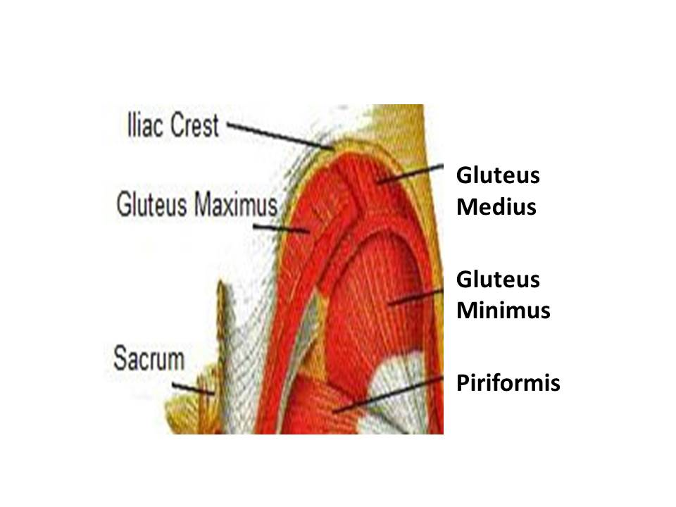
Ref: MACKENZIE, B. (2012) Gluteus Maximus [WWW] Available from: http://www.brianmac.co.uk/glutes.htm [Accessed 4/4/2016]
Many women believe that weightlifting will bulk them up and make them pack on large amounts of muscle. This is a common myth which I will briefly explain! Women produce oestrogen (female hormone) which differs from guys who produce testosterone (male hormone). Testosterone is what helps men build muscle but ladies don’t really produce it. So, you will never get “too bulky” from lifting weights especially with a good diet. What you can expect is a great, well defined, strong and sought after physique. As long as you put in the work of course

WHAT YOU WILL GET FROM THIS TRAINING PROGRAMME

- A bigger, tighter and firmer butt
- Smaller tighter waist (Helped from a clean diet and well organised exercise guide)
- You’ll look amazing in your bikini and feel summer ready
- Tighten and Tone-Up
- May experience Weight Loss
- Will experience Stress Relief

The programme that you will be following over the next 7 weeks, requires you to train your legs 3 times a week! I know that the idea may seem radical at first but you will see the benefits when you give it a go.

You will train on a Monday, Wednesday and a Friday. On Tuesday’s and Thursday’s feel free to work your upper bodies and core. This programme is mainly focussed on lower body development though.

In the following pages I will go through each of the three days with you and explain what each one means, why you should do it and why it is important to achieve the goal of building a better butt.

FIRST DAY - STRENGTH TRAINING

ABOUT STRENGTH

Being strong doesn’t necessarily mean that you are bulky or masculine! Being strong is a good thing. Strength will help your discipline and ensure future progress by making those muscles work harder.

With strength training you will grow your muscles and at the same time decrease your fat by burning more calories and ensuring constant development. The strength workout will be about focusing on using heavier weights with lower rep ranges to really develop that strength. You will, therefore, be strong for your hypertrophy and isolation leg days to make that butt look and feel great.

BENEFITS OF STRENGTH TRAINING

- Stronger Bones
- Weight Management
- Lower Risk of Injury from stronger muscles
- Improved flexibility and balance
- Healthier Heart

THIRD DAY - HYPERTROPHY – WHAT IT IS?

Hypertrophy is when you perform more reps ensuring your muscles burn away fat.

Working in the higher rep ranges maximises the burning and wearing of your butt, thereby ensuring muscle growth and toning.

This helps to reduce cellulite, lose fat, and gain a good butt size.
Performing twenty reps in a set has its values, but not in this case. That sort of rep range is mainly used for muscular endurance and WILL NOT help to build a muscle, especially those muscles found in the butt.

BENEFITS OF HYPERTROPHY TRAINING

- Tone
- Tighten
- Reduce Unwanted Cellulite
- Burn Fat Isolation

Stir-fried vegetables consisting of broccoli, peppers, mushrooms, carrots, bean-sprouts, red onions, asparagus
1 cup of quinoa
1 cup of lentils

With small portion of wholegrain rice approx. 70g

Night time snack:

Peanut butter spread onto 4 Ryvita. Do not use butterProduced by James Monk (BAHons) - Tel: 07584639508

